Sites that use line:

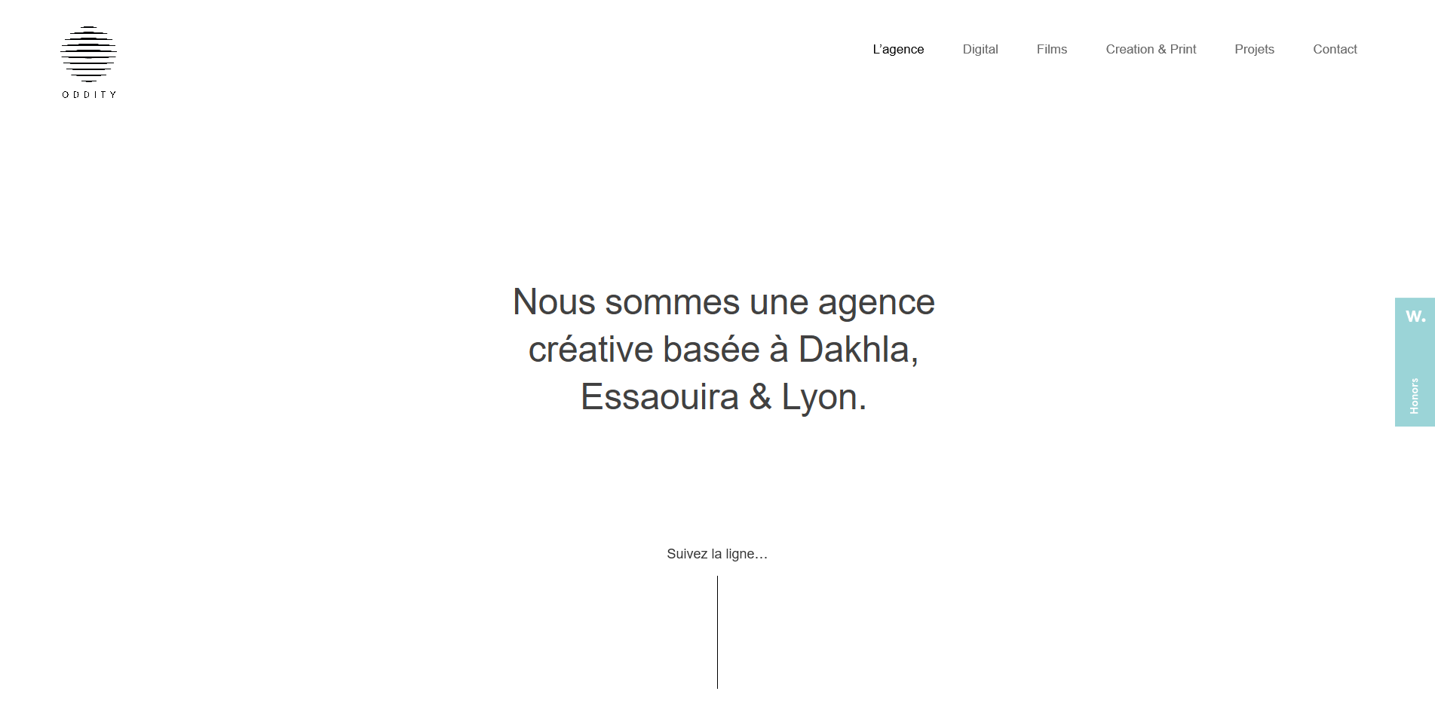

<https://old.oddityline.com/>

* This site uses a single line which leads the eye downward towards the different content throughout the site.



<https://www.gabiano.it/contatti>

* This site uses smooth curved lines to measure the length of its content.

Sites that use shapes:



<https://www.campaignmonitor.com/company/annual-report/2016/>

* This site uses a lot of different shapes the numbers themselves are also used as shapes.



<https://beamery.com/>

* This site uses a wide variety of shapes spread throughout the entire page.

Site that uses depth:



<https://www.versionsapp.com/>

* depth is achieved on this website through the use of a landscape, lighting, and shadows. The colors that are used give the picture an almost 3d effect.